**Conda Interpreter**

1. Create Conda virtualrtual env

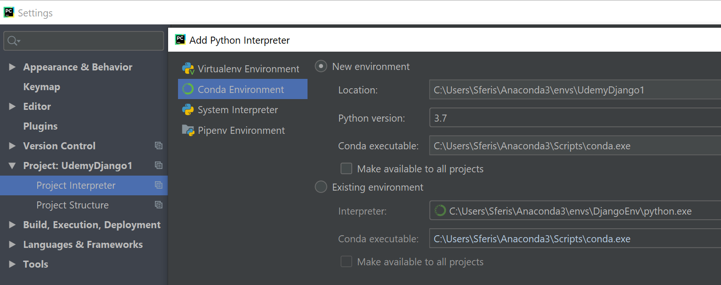

# „Please Specify a different SDK” ---→ Delete env with the same name or all if needed

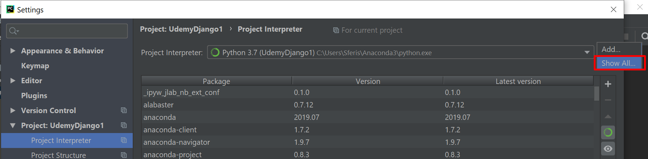

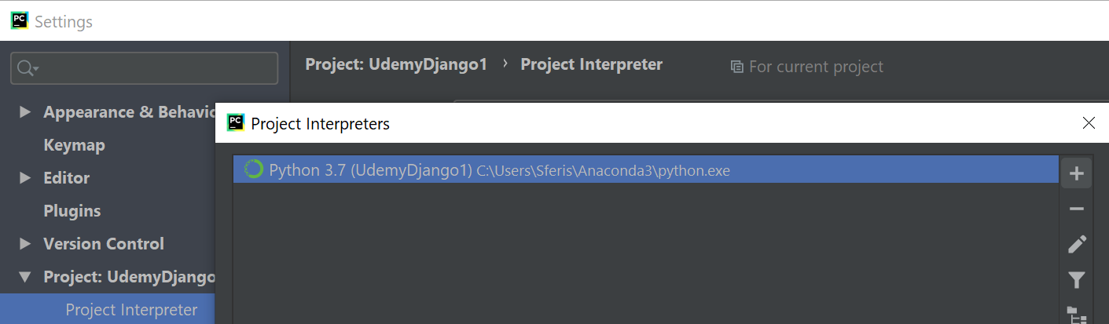

**IF NOT WORKING:** <https://appuals.com/fix-conda-is-not-recognized-as-an-internal-or-external-command-operable-program-or-batch-file/>